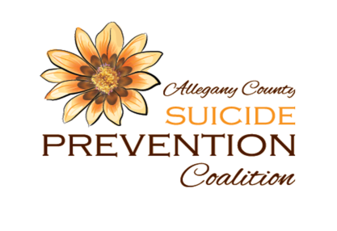
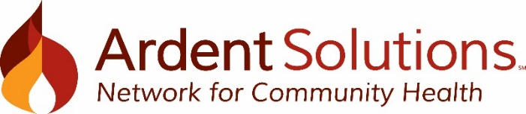
Allegany County Suicide Prevention Coalition Meeting Minutes

Date: Thursday, May 6, 2021 Location: Zoom Time: 2:30 – 3:30pm
Mission: We are committed to embracing life by being a resource for suicide prevention, intervention and postvention
Vision: All people know they are valued and therefore are empowered to live.
Core Belief: We believe all people have inherent value, deserve respect, and have purpose.
- Attendees: Ann Weaver, Janice Porter, Jo Dickens, Suzanne Krull, Sheriff Rick Whitney
- Agenda and Action items:

Agenda Item | Talking Point | Action
New Business | - 2021 Meeting Schedule  - May is Mental Health Awareness Month  - Soul Shop – faith-based suicide prevention model  - Supporting Mental Health Resources/ Letter to Education | - July 1, September 2, November 4 from 2:30 – 3:30pm. Meetings will be virtual for the foreseeable future.  - Reviewed ways we can support Mental Health 4 All for:  Yourself – open up to someone close, identify 3 self-care activities, familiarize self with crisis resource numbers  People in your life – identify self as a safe person to talk about mental health, actively listen when someone asks for help, connect people who have shared interests.  Your community – Advocate, get involved, and bring mental health educational topics to your community  - Soul Shop – the WNY Chapter of the American Foundation for Suicide Prevention (AFSP) is budgeting for a Soul Shop to be hosted in our region in 2022. Soul Shop is a one-day workshop designed to equip faith community leaders to minister to those impacted by suicide. This includes the creation of worship resource, training congregation members in suicide awareness and basic conversation skills, and the how to extend the invitation to those who have been suicidal in the past to share their stories.  - New York State Education Department and Office of Mental Health sent a joint letter with guidance on supporting students’ mental health. The coalition members reviewed the letter’s resources. JS will follow-up with Community Services to verify if it was received in Allegany County. Letter will be attached with the meeting minutes. Resources were developed for school leaders, parents/families and for students.
Messaging and Awareness | - Newsletter  - Recruitment  - May is Mental Health Month  - National Prevention Week is May 9 – May 15, 2021 (substance use & mental disorders)  - September- National Suicide Prevention Month & Week | - Summer and Fall  - Coalition members identified opportunity to recruit faith community leaders  - Awareness campaign per AFSP, Mental Health 4 All  - JS wrote a blog to be published by PPAC during National Prevention Week  - Will explore an ad-hoc committee at July meeting to plan for Suicide Prevention awareness month
Programs and Events | - Youth Mental Health First Aid Trainings  April 16th & May 15th  - Talk Saves Lives  - Exploring ASK Workshop - ASK Workshop is the only suicide prevention workshop that specifically addresses suicide risk in children and gives participants developmentally appropriate strategies and tools to identify young children at risk of suicide and quickly gather and organize key details needed to assess risk and inform safety planning.  - ASIST & Safe Talk remain unavailable | - 9 individuals were trained and certified on April 16th. 10 individuals are scheduled for the May 15th YMHFA  - Seeking suggestions for target audiences  - On hold indefinitely  - New York State employees are under Covid restrictions and remain unable to provide ASIST and SafeTALK trainings. These trainings are required to be in-person and NYS has not opened that back up yet. Tentatively planned to resume in October.
Suicide Response and Postvention | - Surveillance data  - Exploring bereavement support groups & community supports  - Update Postvention packets  - Explore conversion to electronic  - Review content  - Check with AFSP  - Update locations with postvention packets | - Discussion around how challenging it is to acquire data on suicide, suicidal ideation, and suicide deaths. JS will follow-up with Allegany County Dept. of Health, Community Services, Jones Memorial Hospital, and the coroner’s office.  - N/A  - JS will review inventory of postvention packet materials. Janice Porter delivered Postvention packets developed 4 years ago to JS. JS will start an electronic postvention toolkit.
The next full Coalition meeting will take place remotely on September 2nd, 2021 from 2:30 – 3:30pm.
See you there!

